TKS Product Development Tracking: Internal Product Development Tracking System

Document Control

Version | Date | Author | Changes
0.1 | 12-06-2026 | Krishna Shelar | Initial Draft

1. Project Overview
Project Name:
TKS Product Development Tracking
Project Type:
Internal Web Application
Organization:
Techknomatic Services Pvt. Ltd.
Purpose:
TKS Product Development Tracking is an internal web-based application designed to monitor and manage the progress of multiple products under development within the organization. The system provides a centralized platform where employees can update development activities while management can track the overall status of projects in real time.
The application improves transparency, accountability, and collaboration among teams by maintaining product statuses, feature details, and user stories in a single interface.

2. Problem Statement
Organizations often manage product development updates through emails, spreadsheets, and meetings, making it difficult to obtain real-time information about project progress.
Challenges include:
- Lack of visibility into product status.
- Difficulty tracking features and user stories.
- Multiple versions of status reports.
- No centralized system for updates.
- Limited accountability for assigned tasks.
The proposed system addresses these challenges by offering a simple and structured tracking platform.

3. Objectives
The objectives of the project are:
- To provide a centralized product tracking dashboard.
- To monitor product development stages efficiently.
- To maintain feature lists and user stories.
- To enable role-based access control.
- To improve collaboration among teams.
- To provide management with real-time project visibility.

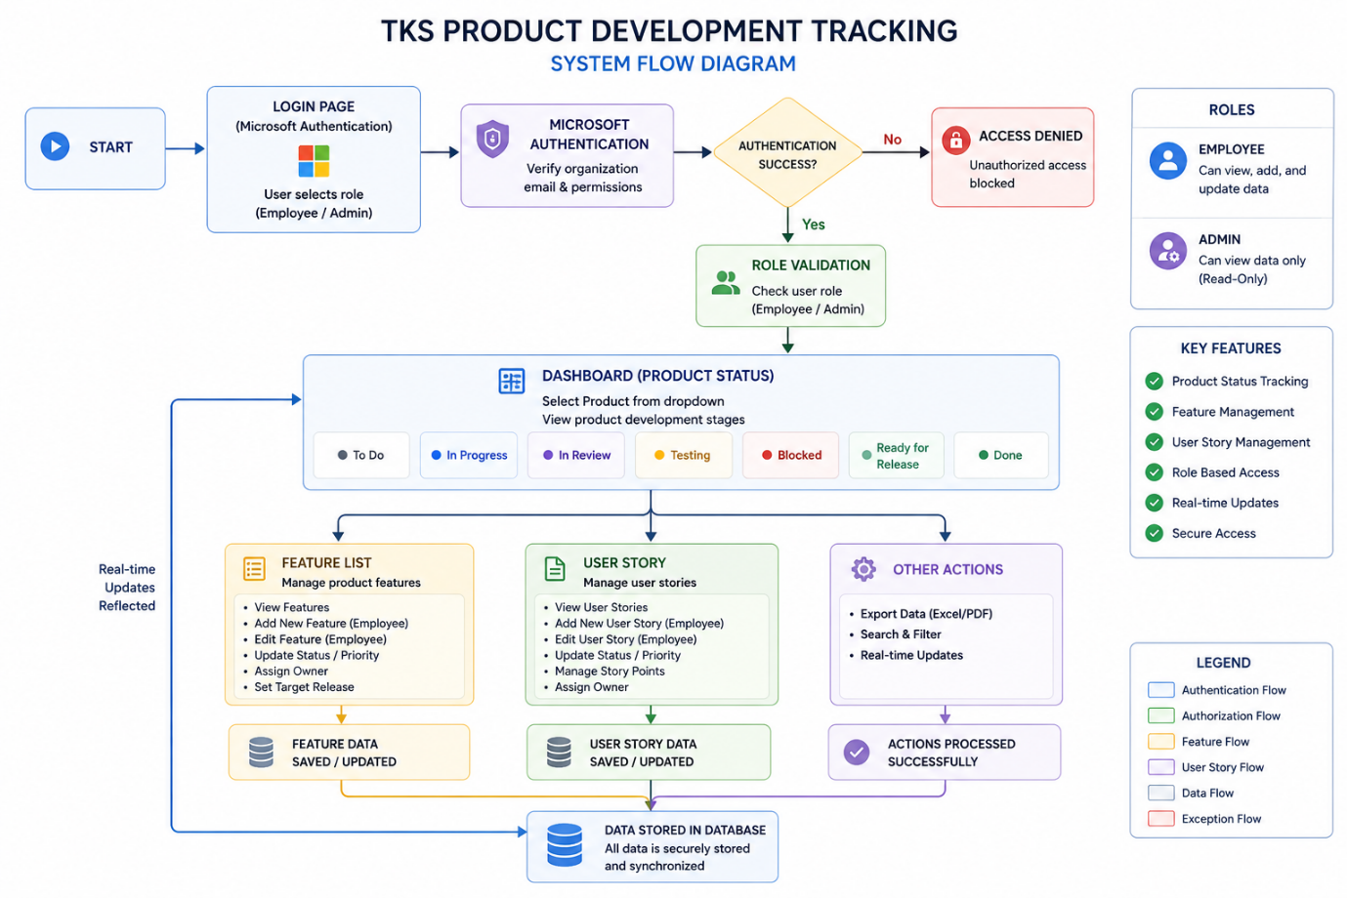
4. System Flow Diagram

Description:
1. Start
The system flow begins when a user accesses the TKS Product Development Tracking application through the web browser.
Purpose:
- Entry point of the application.
- Directs users to the login page.

2. Login Page (Microsoft Authentication)
The login page allows users to authenticate themselves using their official organizational Microsoft account.
Users must select their role before proceeding.
Available Roles:
- Employee
- Admin
Purpose:
- Secure user authentication.
- Role identification.
- Restrict access to authorized users only.

3. Microsoft Authentication
The system integrates with Microsoft Authentication (Azure Active Directory) to verify user credentials.
The authentication service validates:
- Organizational email address
- User identity
- Account legitimacy
- Access permissions
Purpose:
- Ensure secure login.
- Eliminate the need for separate passwords.
- Enable Single Sign-On (SSO).

4. Authentication Success?
After verification, the system checks whether the login request is valid.
If Authentication Fails:
The user is redirected to the Access Denied process.
If Authentication Succeeds:
The system proceeds to role validation.
Purpose:
- Prevent unauthorized access.
- Verify successful authentication.

5. Access Denied
If the user's email is not authorized or authentication fails, access to the application is blocked.
Reasons:
- Unauthorized email address.
- Invalid credentials.
- User not registered in the approved user list.
Purpose:
- Protect organizational information.
- Ensure only approved users can use the system.

6. Role Validation
After successful authentication, the system determines the user's role.
Employee:
Can view and update project information.
Admin:
Can only monitor and view project information.
Purpose:
- Implement role-based access control.
- Assign permissions based on responsibilities.

7. Dashboard (Product Status)
The dashboard is the default page displayed after login.
Users can select a product from the dropdown menu and view its development status.
Product Development Stages:
- To Do
- In Progress
- In Review
- Testing
- Blocked
- Ready for Release
- Done
Purpose:
- Provide a real-time overview of project progress.
- Serve as the central workspace.

Product Status Stage Descriptions

7.1 To Do
This stage contains tasks that have been identified but development has not yet started.
Characteristics:
- Requirements are finalized.
- Resources may be assigned.
- Awaiting execution.
Example:
Feature requirements documentation.

7.2 In Progress
Development activities for the task are actively being carried out.
Characteristics:
- Coding is underway.
- Team members are working on implementation.
- Regular updates occur.
Example:
Developing the login module.

7.3 In Review
Completed work is evaluated by reviewers or senior team members.
Characteristics:
- Code reviews are performed.
- Functional verification occurs.
- Feedback is provided.
Example:
Reviewing completed feature implementation.

7.4 Testing
The developed functionality undergoes quality assurance and testing.
Characteristics:
- Unit testing.
- Integration testing.
- Bug identification.
- Validation against requirements.
Example:
Testing the Product Dashboard module.

7.5 Blocked
Tasks cannot proceed due to dependencies or unresolved issues.
Characteristics:
- Waiting for approvals.
- External dependency exists.
- Technical issues prevent progress.
Example:
Waiting for third-party API credentials.

7.6 Ready for Release
The functionality has passed all validations and is prepared for deployment.
Characteristics:
- Testing completed.
- Stakeholder approval received.
- Release package prepared.
Example:
Feature approved for production deployment.

7.7 Done
The task has been successfully deployed and completed.
Characteristics:
- Production release completed.
- Documentation finalized.
- No further action required.
Example:
Feature available to end users.

8. Feature List Module
This module maintains all features associated with the selected product.
Employees Can:
- View features.
- Add new features.
- Edit feature information.
- Update status and priority.
- Assign owners.
- Set target release versions.
Admins Can:
- View feature information only.
Purpose:
- Manage product functionalities efficiently.

9. Feature Data Saved/Updated
Whenever employees modify feature details, the system validates and stores the updated information.
Purpose:
- Maintain accurate feature records.
- Ensure real-time synchronization.

10. User Story Module
This module captures business requirements using Agile user stories.
Employees Can:
- Create user stories.
- Edit user stories.
- Update priorities.
- Assign owners.
- Manage story points.
Admins Can:
- View user stories only.
Purpose:
- Translate business requirements into development tasks.

11. User Story Data Saved/Updated
Any modifications made to user stories are stored in the system database.
Purpose:
- Preserve updated requirements.
- Support agile development practices.

12. Other Actions
Additional utilities available within the application.
Includes:
- Export reports (Excel/PDF)
- Search functionality
- Filters
- Real-time updates
Purpose:
- Improve usability and reporting capabilities.

13. Actions Processed Successfully
After completing an operation, the system confirms successful execution.
Examples:
- Feature added successfully.
- Status updated successfully.
- User story modified successfully.
Purpose:
- Provide user feedback.
- Confirm data processing.

14. Data Stored in Database
All information generated through the application is securely stored in the database.
Stored Data Includes:
- Product information
- Status updates
- Feature details
- User stories
- Assignments
- Release information
Purpose:
- Maintain a centralized repository.
- Ensure data integrity and availability.

15. Real-Time Updates Reflected
Once changes are saved, the updated information becomes visible across the system immediately.
Benefits:
- Improved collaboration.
- Up-to-date project visibility.
- Better decision-making.
Purpose:
- Keep all stakeholders informed using the latest data.

5. System Users
The application supports two types of users.
5.1 Employee (User)
Employees are team members actively involved in product development.
Responsibilities
- Update product statuses.
- Add new features.
- Edit feature information.
- Create user stories.
- Update user stories.
- Modify status of assigned tasks.
- View all product-related information.

5.2 Admin
Admins are project managers or department heads responsible for monitoring development activities.
Responsibilities
- View complete product information.
- Monitor progress across products.
- Review feature lists.
- Review user stories.
- Track project health.
Restrictions
Admins have view-only access and cannot modify project data.

6. Authentication and Login Access
The system uses secure authentication to restrict access to authorized personnel only.
Login Methods
Microsoft Authentication (Single Sign-On)
Users can sign in using their official organizational Microsoft account.
Benefits:
- Secure authentication.
- No need to remember separate passwords.
- Integration with company identity management.
- Simplified user experience.

Email Access Restriction
Only pre-approved email addresses are allowed to access the application.
Example:
krishna@company.com
employee1@company.com
admin@company.com
Unauthorized users will be denied access.

7. Dashboard Modules
The application consists of three primary modules.

Module 1: Product Status Dashboard
This is the default page after login.
Purpose
Displays the current status of the selected product.
Product Selection
Users can select products using a dropdown menu.
Example:
TechCRM Platform
AI Analytics Portal
HR Management System
Customer Support Tool
Once selected, the corresponding product details are displayed.

Product Development Stages
The dashboard displays product progress using the following statuses:
Stage | Description
To Do | Work not yet started
In Progress | Development is ongoing
In Review | Work under review
Testing | QA and testing phase
Blocked | Progress halted due to dependencies/issues
Ready for Release | Approved and ready for deployment
Done | Successfully completed

Module 2: Feature List
Displays all features associated with the selected product.
Information Captured
- Feature ID
- Feature Name
- Description
- Status
- Priority
- Owner
- Target Release Version
Employee Permissions
Employees can:
- Add features
- Edit features
- Update statuses
- Change priorities
- Assign owners
Admin Permissions
Admins can:
- View feature information only.

Module 3: User Story Management
Displays user stories linked to product features.
Information Captured
- User Story ID
- User Story
- Related Feature
- Description
- Status
- Priority
- Story Points
- Owner
Example User Story
As a user, I want to log into the system so that I can securely access my account.
Employee Permissions
Employees can:
- Add user stories.
- Modify user stories.
- Update story status.
- Edit story points.
Admin Permissions
Admins can only view user stories.

8. Functional Requirements
The system shall:
- Allow secure login.
- Support Microsoft authentication.
- Restrict access to approved users.
- Display product information.
- Allow product selection.
- Display status dashboard.
- Manage feature lists.
- Manage user stories.
- Support role-based access.
- Provide real-time updates.
- Maintain data consistency.

9. Non-Functional Requirements
Performance
- Dashboard should load quickly.
- Status updates should reflect immediately.
Security
- Microsoft authentication.
- Restricted email access.
- Role-based authorization.
Usability
- Simple and intuitive interface.
- Minimal learning curve.
- Responsive design.
Reliability
- Accurate data presentation.
- Stable system operation.

10. Technology Stack (Proposed)
Layer | Technology
Frontend | HTML, CSS, JavaScript
UI Framework (Optional) | React.js
Backend | Node.js / Express.js
Database | MySQL
Authentication | Microsoft Azure AD
Hosting | Internal Server / Cloud
Version Control | Git & GitHub

11. Future Enhancements
The following features can be added in future versions:
Notifications
- Email notifications for status changes.
- Reminder notifications for pending tasks.
Reporting
- Download reports in PDF and Excel format.
- Generate weekly progress reports.
Analytics Dashboard
- Product-wise completion percentage.
- Team productivity metrics.
- Blocked task analysis.
- Release readiness indicators.
Audit Logs
- Track who made changes.
- Maintain modification history.
Comments and Discussions
- Team discussions under features.
- Feedback during reviews.
Attachments
- Upload requirement documents.
- Add screenshots and supporting files.

12. Benefits of the System
- Centralized tracking platform.
- Improved transparency.
- Better collaboration among teams.
- Faster decision-making.
- Reduced dependency on manual reporting.
- Enhanced accountability.
- Real-time project visibility.
- Secure access control.

13. Conclusion
The TKS Product Development Tracking System provides an efficient solution for monitoring and managing internal product development activities. By integrating status tracking, feature management, user story management, and secure role-based access, the application enables employees and management to collaborate effectively while maintaining complete visibility into project progress.
The system serves as a single source of truth for product development activities and can be further enhanced with reporting, analytics, notifications, and audit capabilities to support the organization's growing needs.

